**Sigma Xi, The Scientific Research Society**

EXCITATION OF THE HYDROCARBON DOUBLE BOND Author(s): A. KEITH BREWER

Source: *American Scientist,* Vol. 56, No. 3 (AUTUMN 1968), pp. 254-264 Published by: Sigma Xi, The Scientific Research Society

Stable URL: <http://www.jstor.org/stable/27828189> Accessed: 29-03-2017 20:59 UTC

JSTOR is a not-for-profit service that helps scholars, researchers, and students discover, use, and build upon a wide range of content in a trusted digital archive. We use information technology and tools to increase productivity and facilitate new forms of scholarship. For more information about [JSTOR, please contact support@jstor.org.](mailto:support@jstor.org)

Your use of the JSTOR archive indicates your acceptance of the Terms & Conditions of Use, available at <http://about.jstor.org/terms>

*Sigma Xi, The Scientific Research Society* is collaborating with JSTOR to digitize, preserve and extend access to *American Scientist*

This content downloaded from 134.197.214.19 on Wed, 29 Mar 2017 20:59:41 UTC [All use subject to http://about.jstor.org/terms](http://about.jstor.org/terms)

AMERICAN SCIENTIST, *56,* **3,** pp 254-264, 1968

**EXCITATION OF THE HYDROCARBON DOUBLE BOND**

# By A. KEITH BREWER

# HE mechanism for the excitation of the hydrocarbon double bond possesses an academic interest in itself. The major interest, how­ ever, should be in its implementations, physical, chemical, and biological. In this paper, three types of excitation means will be discussed, i.e., elec­ tron impact, ultraviolet light irradiation, and thermal. Possible imple­

T

mentations !l,nd applications will be considered.

The writer first became interested in double bond excitation when he observed in 1931 that microorganisms could be made to fluoresce and phosphoresce upon exposure to ;>.. 2536. A study of the literature revealed that the underlying basis for this observation had long received the critical attention of many outstanding physicists in Europe.

An initial crude attempt to excite this double bond by electron impact met with failure. A later extension using the mass spectrometer revealed that the phenomena involved in excitation were much more complicated than had initially been supposed. As a consequence of this study it has been possible to construct a model for the excited bond which not only will account for associated observations, but has made it possible to suggest new methods for microorganism detection and analysis, as well as to explain many phenomena involved in vital processes. The proposed model is one that shows excitation to be a similar process whether induced by radiation, heat, or electron impact. The actual distribution of energy between the various processes involved may, however, not be indepen­ dent of means of excitation.

*Excitation of the Double Bond by Electron Impact*

The mass spectrometer cracking patterns for hydrocarbons provide a means for studying the mechanism involved in the excitation of the hydrocarbon double bond. In practice, ions are formed by bombardment with 50 volt electrons [lJ. This voltage is sufficient to break down the hydrocarbon molecule into a variety of fragmentation products. By sweeping the bombardment voltage, the appearance potential for the various fragments can be determined; this is not a part of the present study except to note that double bonds are very much more stable than single bonds.

Four types of peaks occur in the 50 volt cracking patterns of most hydrocarbons. These are (1) singly charged masses consisting of the whole molecule and its breakdown fragments; (2) doubly charged fragments;

254

EXCITATION OF THE HYDROCARBON DOUBLE BOND 255

(3) ghosts; and (4) rearrangement masses. These will be discussed sepa,­ rately.

*Singly Charged Fragmentation Masses:* The cracking pattern for most hydrocarbons upon bombardment by 50 volt electrons shows singly charged masses corresponding to essentially all possible fragmentation products. The *C* mass itself seldom appears. Time of travel measurements in the conventional ionization chamber shows that fragmentation takes place in less than 10-7 sec; the exact time may be as short as **10- 13** sec.

*Double Charged Ions:* Double charged masses appear only for groups in which the binding energy is high,

such as double bonded molecules **EXCITED DOUBLE BOND**

or radicals.

*Resonance Masses:* Resonance mass fragments occur at larger

mass numbers than can be real­

ized from direct fractionation of the parent molecule. Thus, mass 15 in the cracking of ethylene can

only result from the transfer of an

*-5*.*-*.

*.;i:.·*

**GROUND STATE**

c·-

**A. C**

-

**EXCITED STATE**

**H** atom from **C-1** to C-2.

Typical examples of resonance masses are listed in Table **1.**

***-5***•***-***. - -

-**C** ,-. -

**B.**

**H**

.. +

**C** - -

The mechanism involved in

/ **o-.i *,f>***

resonance mass formation is illus- Figure 1

trated **in** Figure **1.**

The normal molecule (A) **H2C= CHR** is struck by an electron, (e) possessing sufficient energy to eject an electron from the molecule leaving it with a positive charge. The energy of impact also excites an H atom on C2 enhancing its amplitude of oscillation between atoms C1 and C2. The number of H atoms within the field of the C1 ion is thus either 2 or 3 depending on the position of the oscillating H atoms at the instance of the

fracture of the C1 = C2 bond. The ratio of the two masses will then be

determined by the fraction of time the H atom is predominantly in the field of each of the two *C* atoms; i.e., by its amplitude and its oscillation path.

Reference to Table 1 brings out a number of significant facts. These are listed briefly:

The ratios for various rearrangement masses show that resonance amplitude is determined by the bond itself as is illustrated with ethylene and acetylene.

The most significant point to note is that the resonance ratios are directly related to the atomic configurations associated with the double bond. This is clearly illustrated by comparing 15/14 for ethylene and butadiene.

256 AMERICAN SCIENTIST

TABLE 1

Compound Acetylene

Ethylene

Propene

Propadiene

1. Butene
2. Butene

Isobutene

Structure

H

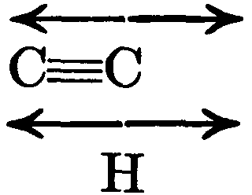

H

+--­

HC=CH

+---

H

H H

( )

HC=C-CH

--

+--­

H H

H

HC=C=CH

+--­

H

H H H H

HC=C-C-CH

# H H

H H H HC-C=C-CH H H H

H

**H,t..C"-** H

**tH** C=CH

# H/

!H C H

Mass

14/13

15/14

29/28

15/14

27/28

30/29

29/28

28/27

29/27

Ratio

0.042

0.093

0.038

0.063

0.8

0.07

0.45

1.0

0.5

Pentene 2

H H

HaC-C=C-C-CHa

# H H

43/42

0.021

# The very high 27/26 ratio for benzene shows a very strong H resonance. This is of particular interest in that it reflects on the structure of the cyclic molecule. On the basis of the evidence, the Kekule formula would appear to be a statistical configuration, the H atoms actually resonating between the various C atoms. Another significant factor is the tendency for H atoms to split off in pairs. This is a direct consequence of resonance in which an atom penetrates the field of its neighbor. It is basic to the synthesis of benzene derivatives as will be discussed later.

*Ghosts:* Ghosts are of interest in that they throw light upon the mech­ anism involved in the metastable state. Ghost peaks are obtained from highly excited ionized masses which pass through the entire accelerating

EXCITATION OF THE HYDROCARBON DOUBLE BOND 257

TABLE 1 *(Continued)*

H H H

1-3 Butadiene

Benzene

Isoprene

2 Me Butene 1

2 Me Butene 2

Cyclopentene

Me Cyclopentane

Vinyl Cyclopentene

HC=C-C=CH

H

HJC=CJH

"'

HC / CH

'\- *,f'*

HJC-CJH

H H

HC=C-C=CH

H I

HOH

H

H H H

HC=C-C-CH

l H H

HCH

H

H H H

HC-C=C-CH

H I H

HCH H

HHHH

C=C-C-C-CH,

I 7H I

1. H, H, H, H,

CH3- C- C- C- C- C

1. I

H, H H H H, H, H,

C=C-C=C-C-C-C

I I

15/14

28/27

27/26

28/26

27/28

27/29

41/42

41/40

41/42

28/29

42/43

14/15

28/29

42/43

28/29

42/43

56/57

28/29

0.91

0.635

0.985

0.081

0.098

0.083

0.57

0.25

1.19

4.83

0.058

6.72

0.593

0.156

1.01

0.395

0.001

0.39

field of the mass spectrometer as mass, *m* +, but are disrupted into masses m1 + and upon entering the magnetic resolving field. To illustrate: in n-butane the base peak is mass 58 *(m+).* Mass 43, however, is 7.34 fold greater than mass 58 in the cracking pattern; thus, the dissociation of mass 58 into masses 43 and 15 is the dominant step. Should C-1 of the undissociated mass 58 be positively charged then C-4 will be negatively charged by induction. In traveling through the acceleration field the

positive end of the molecule will lead. Upon entering the electrical field­ free region of the magnetic resolution chamber the + end of the molecule

will have imposed upon it a force tending to deflect it to the right, say, while the - end will be deflected to the left. If the ion possesses energy

258 AMERICAN SCIENTIST

just insufficient for dissociation, this imposed torque may be sufficient to cause fragmentation.

Since mass 43 has the velocity imparted to mass 58 it will not appear at the 43 mass position but will be resolved according to the equation

*m'(m' /m)v* = *Her* (1)

where vis the velocity upon entering the field *H, e* is the charge, and *r* is the deflection radius. Thus, the mass position for the ghost from *n­* butane is 432/ 58 = 31.9.

Actually ghost peaks tend to be displaced from 0.1 to 0.2 mass units from that given by equation (1) toward heavier masses; this is to be expected since the drag of the negative portion of the ion at the moment of splitting will tend to increase the radius of curvature. Ghost peaks for 50 volt electrons seldom exceed 0.01 of the source peak. Ghosts may arise from the loss of H2, and from C1, C2, and Ca radicals singly or in pairs.

The ghost fragmentation is not always a single unit process. It may

involve association as illustrated by the appearance of H2, and by the 29 peak for isobutene. Again, it may result from a multiple dissociation; for example, the 24.5 peak is due to the loss of mass 30 from mass 72. Mass 42 has an abundant peak while mass 30 exists only as isotope from 29; mass 30, therefore, must represent multiple fragmentation. Mass num­ bers resulting from the loss of 16 are also examples of multiple dissocia­ tion.

Since peak 58 is moderately large in the cracking pattern for n-butane and since peak 31.9 is about **0.01** in comparison, it follows that only a small fraction of the metastable 58 mass can be dissociated by the im­ posed magnetic torque. The resonance concept presented here suggests that fracture occurs when the position in the cycle coincides with the time at which the torque is applied, thus increasing the amplitude to the point where rupture is possible.

*Excitation of the Double Bond by Ultraviolet Light*

The fluorescence and phosphorescence of microorganisms upon ir­ radiation by ultraviolet light are to be expected from the double bonds present in amino acids. Fluorescence involves the emission of light in the ultraviolet (uv) region upon irradiation by uv of a shorter wave length. The emission takes place primarily in 10-s (10- 7 to 10- 9) seconds follow­ ing irradiation. Phosphorescence refers to the emission of visible light following irradiation by uv light; the emission may last for many seconds up to one minute or more.

*History:* Induced luminescence was discovered by Robert Boyle in 1648. Sir John Herschel in 1845 reported on induced luminescence in quinine. A year later Sir David Brewster observed a similar effect in chlorophyll. Sir George Stokes, starting with quinine, examined many organic mate-

EXCITATION OF THE HYDROCARBON DOUBLE BOND 259

rials. He then enunciated Stokes Law, which states that theemitted light is always of a longer wave length than the exciting light. Stokes first sug­ gested the term fluorescence.

E. Becquerel in 1867 devised a phosphorescope for studying long-lived emissions from sulfides and organic crystals; he showed that the phos­ phorescent light intensity decayed exponentially with time. In 1892 Lenard concluded that thespectrum of phosphorescent light consists of a number of overlapping bands. In 1895 Sir James Dewarshowed that many organic substances when cooled to liquid air temperatures would phos­ phoresce upon uv irradiation. A short while later Lenard, Onnes, and Pauli reported that "for each band in the spectrum of a body excited to phosphorescence there is a certain range of temperatures within which it is phosphorescent, and above and below which no phosphorescence of long duration occurs, although fluorescence may be present."

In 1904 Lenard and Klat analyzed some 800 phosphors, primarily metallic and organic sulfides. They concluded that phosphorescence was

due to the falling back of an electron which had been separated to the surrounding space. The return must involve collisions hence *-dn/dt* =

*}-n,* and thus

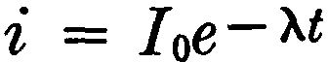

where *I* is the initial intensity and A is the decay constant.

(2)

Werner showed the process was more complicated than suggested by equation (2), and that the phosphorescent intensity for many substances was given by

i = *J0e - >.tm* (3)

where *m* for most of the materials tested varied from 0.2 to 1.

Werner's results were in agreement with Lenard's suggestion that "the vibrations set up on a phosphorescent substance are analogous to those of an electric oscillator having a period dependent on inductance and capacity, and that the wave length of a band is proportional to the square root of the dielectric constant of the medium."

Between World War I and II work lagged in this field. Possibly the most impressive work was that of Jablonski *(Zeits f. Physik, 94,* 38, 1935) who set up a workable energy diagram. This diagram was elabo­

rated during World War II by Lewis, and by Franck and their co-workers.

Lewis modified the Jablonski theory and showed that fluorescence is a singlet-ground transition while phosphorescence results from a singlet to triplet shift with emission following the triplet to ground transition. Lewis further extended the work to a very large number of hydrocarbons containing double bonds. All were shown to fluoresce and to phosphoresce under proper excitation conditions.

Recent work has taken two directions, one to show that organic mate-

260 AMERICAN SCIENTIST

# rials can be made to fluoresce and to phosphoresce [21, and the other to embellish the singlet-triplet state theory [3J. Unfortunately, there has been little attempt to use phosphorescence decay as an analytical tool. Essentially no work has been done in determining the fine structure of the fluorescence spectrum or in its use in quantitative analysis.

A number of papers have appeared showing fluorescence and phos­ phorescence in biological materials. The decay constants observed were of the type given in equation (3). In general, it has been concluded that "organic structures are too complicated to obey a simple decay law," hence no attempts have been made to evaluate much less explain the exponentm.

*Theory:* The mechanism for fluorescence and phosphorescence de­ scribed here has been developed to explain the observed phenomena, as

related to the C = C bond, and to provide a means for the practical

analytical applications of the pro­

DOUBLE BONO ENERGY DIAGRAM

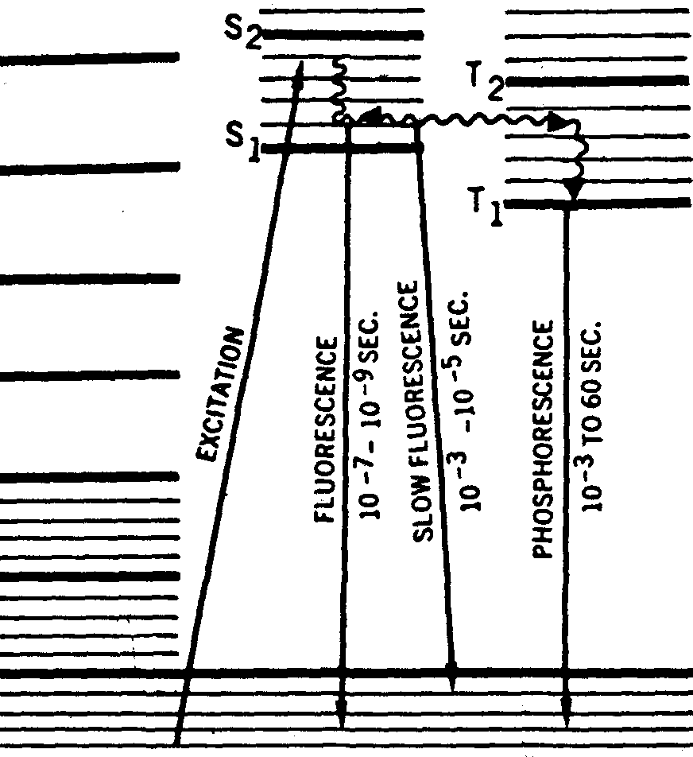

t-- T-------

|  |  |
| --- | --- |
| NON MAGNETIC | MAGNETIC |
| THERMAL I SINGLET | TRIPLET |

GROUND STATE

··· ··u

Figure 2

# cesses involved. Figure 2 is a mod­ ified Jablonski energy diagram.

The double bond depicted in A of Figure **1** is irradiated with ul­ traviolet light of wave length in

the range 2700 A ± 200. The elec­

# tron is raised to a level in the *S* range as shown. The electron here may take a number of paths. It may drop back to the ground state in a time of the order of 10-s seconds with the emission of

fluorescent light having a wave length 500 ± 400 A longer than

# the exciting light; this is ordinary fluorescence. It may ospillate be­ tween the *S* and *T* states and then

fall back to ground in a time of the order of 10 --:4 sec; this is slow fluores- cence.

Again it may oscillate between the *S* and *T* states, but if the bond is stabilized by incorporation in a crystal lattice or preferably by cooling to liquid nitrogen temperature, then the electron will have time to go into parallel spin with its paired electron. In this state the electron is mag­ netically stabilized and will continue to rotate until it picks up energy by collision from an outside source.

Upon collision, which is determined by probability, the electron will be knocked out of its stabilized state. It can then fall back to the ground

level with the emission of phosphorescent light. The wave length 1s, in general, in the visible range primarily 5000 ± 1000 A. ·

EXCITATION OF THE HYDROCARBON DOUBLE BOND 261

The number of collisions is given by *-dn/ dt* = }.. *n* hence

i, = *I0e- >..t* (2a)

In the magnetically stabilized state the bond is paramagnetic and should exhibit paramagnetic spin resonance. It follows then that the decay in paramagnetic spin resonance must be concomitant with the de­ cay in phosphorescence.

Reference to Table 1 reveals that the field existing at a double bond is dependent upon the atoms associated with the bond. This is illustrated figuratively in Figure **lB.**

In virtue of the above it is not too surprising that Lenard, almost **100**

years ago, should conclude that, in phosphorescence decay, the bonds act like tuned circuits. Nor is it surprising that the decay should be ex­ pressed by i = *Ioe->..tm,* although the real significance of the deviation' from a pure exponential was missed.

On the basis of information presented in Table 1, the writer suggested some years ago that the decay in light intensity from an organic mate­ rial, such as protein, which contains a plurality of double bonds, should be expressed by the following equation:

 (4)

where i is the integrated intensity from all the resonators, and 1, 2 ... *n*

refer to the emissivity from specific bond configurations.

That this equation can be applied as a means for the analysis of or­ ganic materials will be shown in the last section of this paper.

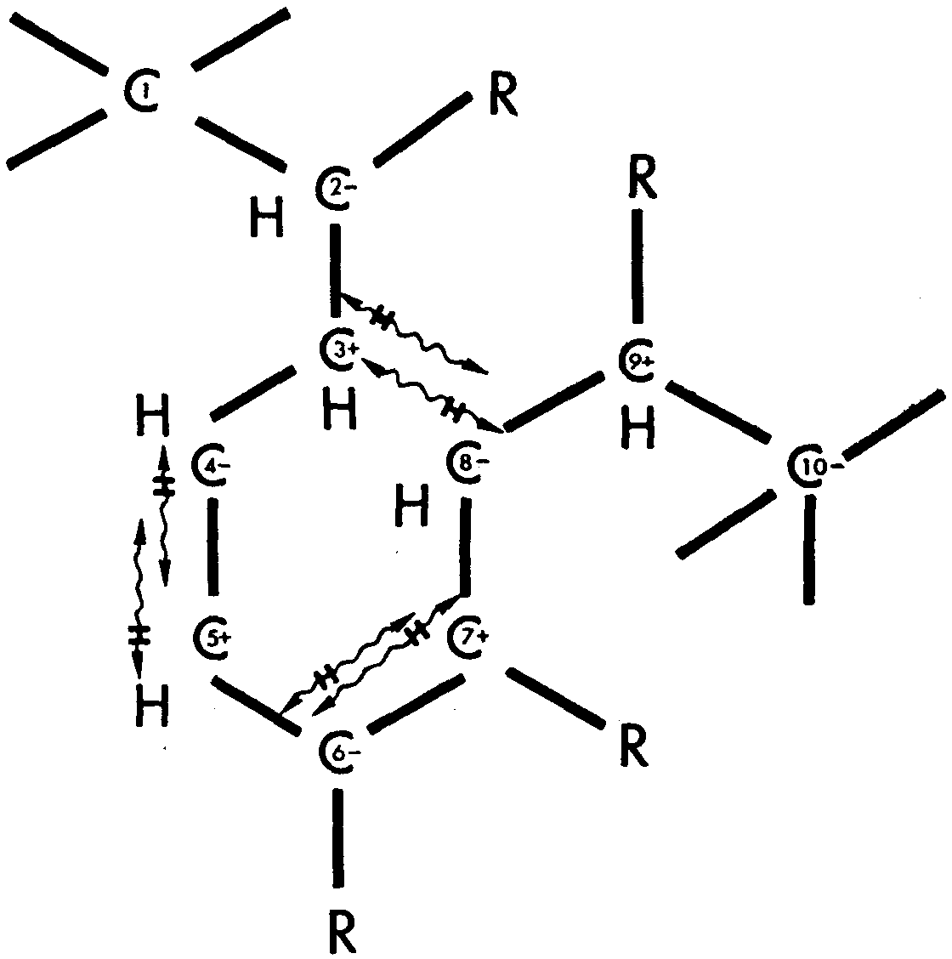Since the resonance of the H atoms associated with double bonds is characterized by the as­ sociated atomic configurations, it is to be expected that light ab­ sorption frequencies will also be so associated. In general, the more complex the molecular con­ figuration, the longer the thresh­ old for uv absorption; this wave

length may range from 1900 A

for ethylene to 3000 A or more for

large molecules. Figure 3

*Thermal Excitation of the Double Bond*

The resonance concept presented in Figures 1 and 2 suggests that this type of activation should be induced by heat as well as by electron im­ pact, and by radiation. The possibility was tested by placing about one milligram of various polymers in the side arm of a small still that could be

262 AMERICAN SCIENTIST

heated electrically. The main body of the still was evacuated, sealed off, and then immersed in liquid air. The design was such that gaseous frag­ mentation products could be removed directly from the polymer sample without the chance of secondary reactions.

The results revealed that gaseous products could be frozen out from all the polymers tested. A residue remained in the cell in each instance. A mass spectrographic analysis of the gaseous pyrolysis products showed the presence of cyclics or substituted benzene rings for many polymers. No tests were made on the solid residue.

*Theory:* Figure 3 is an attempt to describe graphically the effect of the thermally induced resonance of the hydrogen atoms on the reactions within the polymer. The tetrahedron configuration of the C atoms may result in atoms C-3 being physically near C-8. Resonance of the H atoms on C-3 and C-8 will induce penetration into the fields of each other. In consequence, H2 can split off from C-3 and C-8 with the establishment of a linkage between these two atoms. The result is the formation of a closed ring structure. Since the H atoms on C-4 and C-5 are again in resonance, H2 will split off to form the double bonds characteristic of the benzene ring. This splitting off of H2 from adjacent C atoms is a highly probable reaction. The benzene rings so formed may contain ortho, meta, or para substitutions, depending on the positions of the associated Rradicals.

*Applications*

The resonance concept presented in Figure 1 is one tl-iat suggests a number of practical applications; it is also one that can 1 e employed in explaining the mechanism involved in a number of obsen ed phenomena. *Phosphorescence:* It was pointed out in a preceding section that the periodicity and hence the phosphorescence decay for double bonds will depend on their associated atomic groupings. Equation (3) was proposed to represent the overall decay from complex organic structures containing a multiplicity of double bonds. With this in mind it was proposed that the sequence of decay constants (Xs) should be specific for various microor­ ganisms. A test of this theory carried out at the Naval Medical Research Institute showed this to be the case. Preliminary results presented in *Nature* [41, revealed that the phosphorescence pattern for a specific microorganism consisted of a summation of the response from a plurality of resonators which were peculiar to the organism. The culture media and

washing solutions were without measurable effect.

Within the limit of error in this study, which, due to the recording means, was quite high, it was not possible to distinguish between living cells and autoclaved cells; any difference that may exist between living

EXCITATION OF THE HYDROCARBON DOUBLE BOND 263

# and dead cells would appear to be of second order. Again the contribu­ tions from the centrifuged fractions showed the wall, the cytoplasm and the capsule to possess the same decay pattern individually as in the whole cell.

*Fluorescence:* The fact that double bonds can be induced to fluoresce when exposed to suitable uv frequencies and that this fluorescence is essentially temperature independent, as shown in Figure 2, has made it possible to suggest a method and means for the detection of microorga­ nisms in the air at distances of several miles as well asfor the detection of double bonded materials in general. This is being covered in a patent application.

Figures 1 and 2 indicate that the fluorescence spectrum should be specific for various double bonds. The available data suggest a semblance of fine structure; it may be possible, therefore, to use fluorescence as an analytical tool, as well as a means for detection.

In addition to applications of the type just presented, the resonance mechanism proposed can be used to account for a number of existing phenomena. A few of these will be summarized.

*Cancer:* Carcinogens are complex molecules containing benzene rings with substitutions in the meta position. Figure 3 shows how such com­ pounds can be synthesized from polymers upon excitation. In the illus­ tration the excitation was thermal. The result, however, will be the same when the polymer is subjected to electron bombardment, irradiated by uv and X rays, or by *a, {J,* and 'Y rays. It is not surprising therefore that can­ cer can be induced in the skin by exposure to uv, by long exposure to heat, and by penetrating radiation. Also it is not surprising that carcinogens appear in both the particulate matter and the vapor arising from the pyrolysis of certain polymers. Again, burned protein such as meat and uv irradiated proteins have been shown to be carcinogenic upon subcuta­ neous injection.

*Cell Reactions:* The excited double bond shown in Figure **lB** should be as reactive as a positive ion to oxygen. The quenching of phosphores­ cence and fluorescence by oxygen is to be expected. This rapid combina­ tion of the bond with oxygen should destroy the natural behavior of the cell wall. In addition, radiation would result in the synthesis of com­ pounds within the cell by the mechanism depicted in Figure 3. Further, the excited bonds within molecular groups associated with DNA should be very responsive to hydrogen bonding and thus induce somatic changes within the cell.

The resonance mechanism presented here can be employed to explain a wide variety of phenomena in addition to those just described. Among these are: sunburn; radiation-induced cancer; the hardening of rubber; cross linkage involved in the aging process; etc.

264 AMERICAN SCIENTIST

*Summary*

The excitation of the C=C bond has been investigated from the standpoint of electron bombardment, ultraviolet absorption, and heat. **A** resonance mechanism has been proposed which has made it possible to propose a number of new analytical procedures. Among these are **(1)** the phosphorescence decay method for the analysis of microorganisms, and (2) the fluorescence technique for the long range detection of micro­ organisms in the air. In addition, the mechanism has been used to ac­ count for the presence of carcinogens in the pyrolysis products of poly­ mers and tissues, and in many organic materials upon irradiation.

REFERENCES

1. **A.** KEITH BREWER, *ASTM Bulletin,* p. 38, May 1946.
2. G. N. LEWIS and KASHA, J., *J. Am. Chem. Soc., 66,* 2100 (1944). R. H. STEELE and A. SZENT-GYORGYI, *Proc. Nat. Acad. Sci., 43,* 477 (1957). J. G. CALVERT and PITTS, Photochemistry, 1966. John Wiley & Sons, N.Y. P. DEBYE and J. 0. EDWARDS, *Science, 116,* 143 (1952).
3. M.A. Eir-SAYED, *Accounts of Chemical Research, I,* p. 8 (1968).
4. S. L. ADELMAN, A. K. BREWER, K. C. HoERMAN, W. SANBORN, *Nature,* 18 Feb. 1967. K. C. HERMAN and MANEEWIEZ, *Arch. Oral Bio., 9,* 517 (1964).